Program 1 - Write a C program to get 3 numbers from the user and print it

#include <stdio.h>
int main() {
int num[3];
printf("Enter 3 numbers = \n");
for(int i = 0; i < 3; i++) {
printf("Number %d: ", i+1);
scanf("%d", &num[i]);
}
printf("The numbers you entered are =\n");
for(int i = 0; i < 3; i++) {
printf("%d ", num[i]);
}
return 0;
}

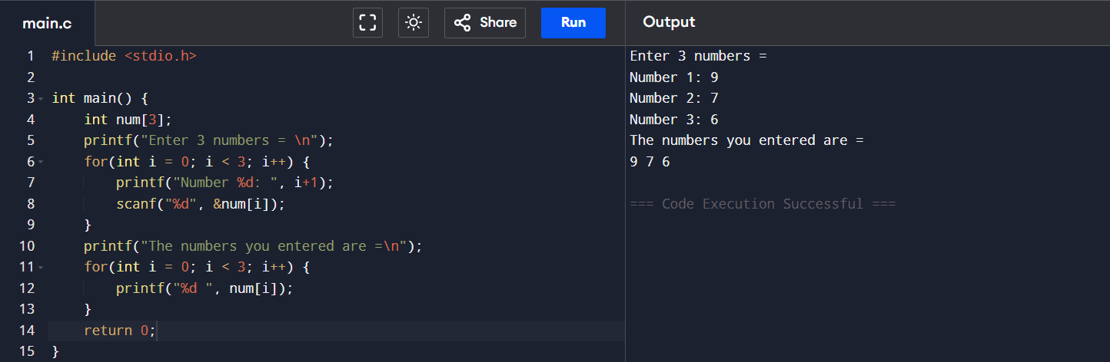

Program 2 - Write a C program to get “n” number from the user and display it

#include <stdio.h>
int main() {
int n, i;
int a[100];
printf("Enter how many numbers = ");
scanf("%d", &n);
printf("Enter %d numbers =\n", n);
for (i = 0; i < n; i++) {
scanf("%d", &a[i]);
}
printf("You entered =\n");
for (i = 0; i < n; i++) {
printf("%d ", a[i]);
}
return 0;
}

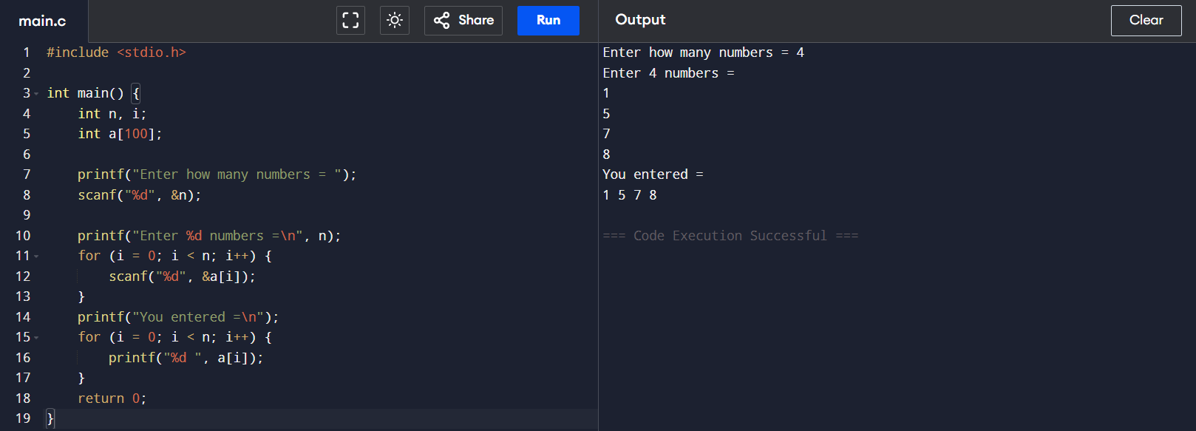

Program 3 - Write a C program to reverse the elements in the array

#include <stdio.h>
int main() {
int a[100], n, i, temp;
printf("Enter number of elements: ");
scanf("%d", &n);
printf("Enter %d elements:\n", n);
for(i = 0; i < n; i++) {
scanf("%d", &a[i]);
}
for(i = 0; i < n / 2; i++) {
temp = a[i];
a[i] = a[n - 1 - i];
a[n - 1 - i] = temp;
}
printf("Reversed array:\n");
for(i = 0; i < n; i++) {
printf("%d\t", a[i]);
}
printf("\n");
return 0;
}

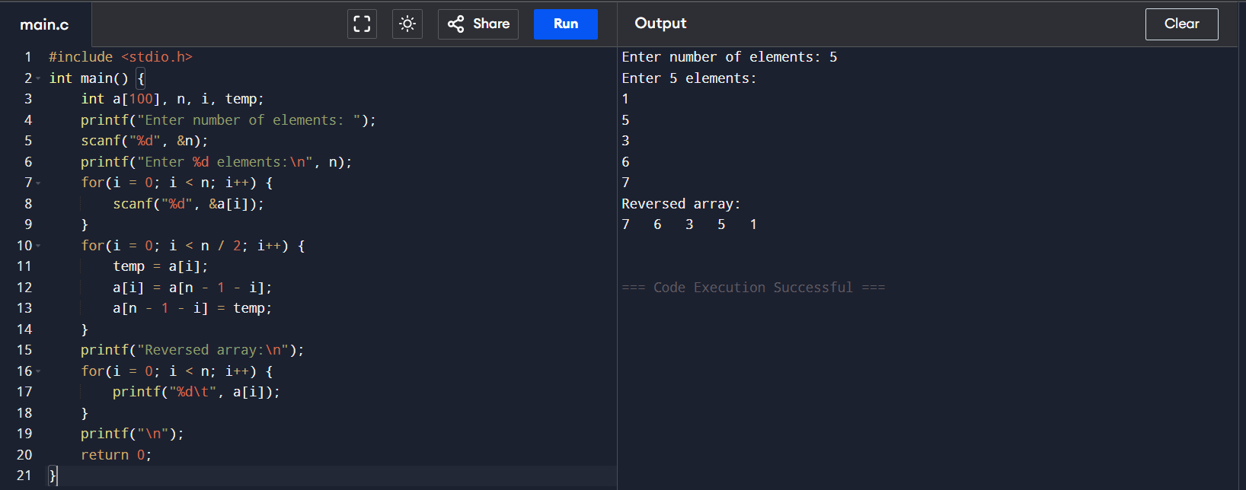

Program 4 - To get the sum of elements in an array

#include <stdio.h>
int main() {
int n, i, sum = 0;
printf("Enter the number of elements: ");
scanf("%d", &n);
int a[n];
printf("Enter %d elements:\n", n);
for(i = 0; i < n; i++) {
scanf("%d", &a[i]);
sum += a[i];
}
printf("Sum of the elements: %d\n", sum);
return 0;
}

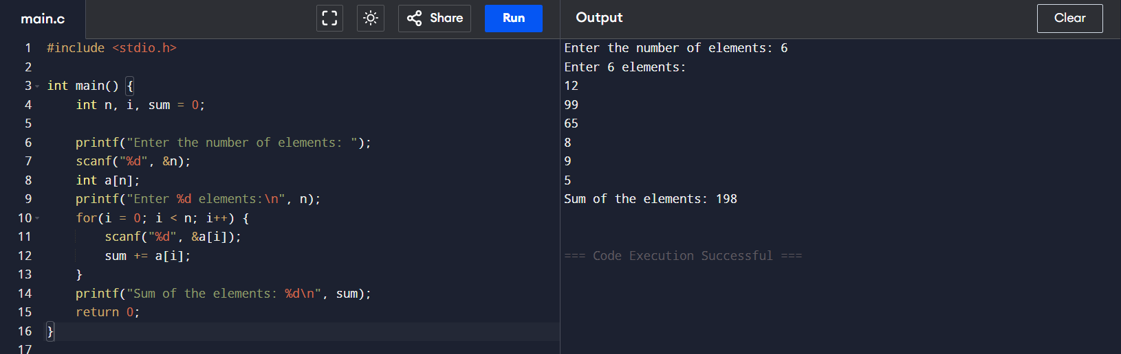

Program 5 - Write a C programs to get the number of elements in an array

#include <stdio.h>
int main() {
int a[] = {22, 33, 55, 66, 77};
int n;
n = sizeof(a) / sizeof(a[0]);
printf("Number of elements in the array: %d\n", n);
return 0;
}

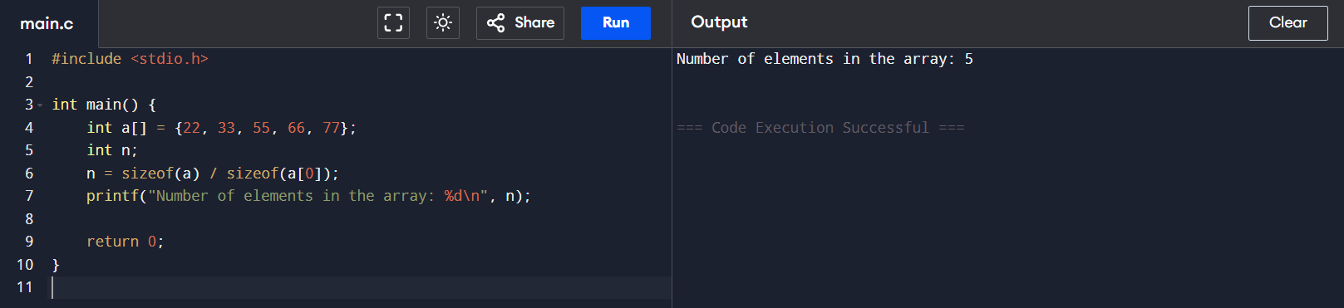

Program 6 - Write a C program to sum the even numbers from an array

#include<stdio.h>
int main(){
int a[100];
int n,sum = 0;
printf("Enter no of elements:\n");
scanf("%d",&n);
printf("Enter the numbers\n");
for(int i=0;i<n;i++){
scanf("%d",&a[i]);
}
for(int i=0;i<n;i++){
if(a[i]%2==0){
sum=sum+a[i];
}
}
printf("The sum of even numbers in array is :%d\n",sum);
return 0;
}

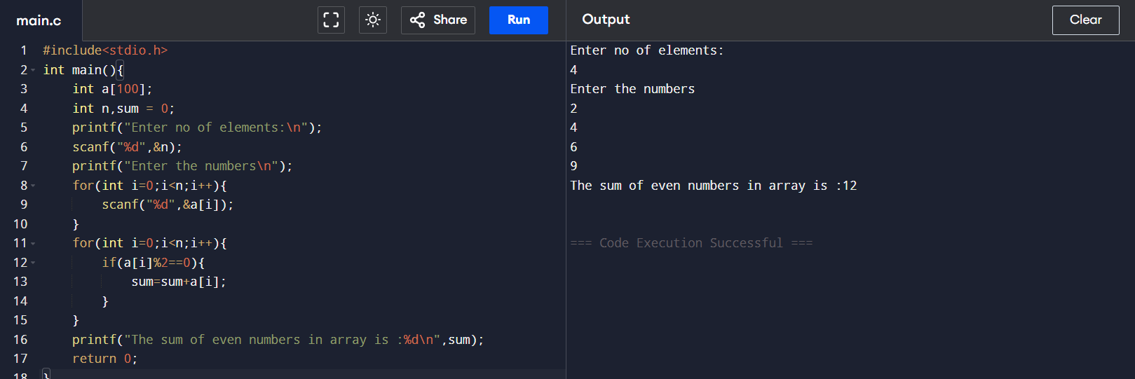

Program 7 - Write a C program to odd the even numbers from an array

#include<stdio.h>
int main(){
int a[100];
int n,sum=0;
printf("Enter no of elements:\n");
scanf("%d",&n);
printf("Enter the numbers\n");
for(int i=0;i<n;i++){
scanf("%d",&a[i]);
}
for(int i=0;i<n;i++){
if(a[i]%2!=0){
sum=sum+a[i];
}
}
printf("The sum of odd numbers in array is :%d\n",sum);
return 0;
}

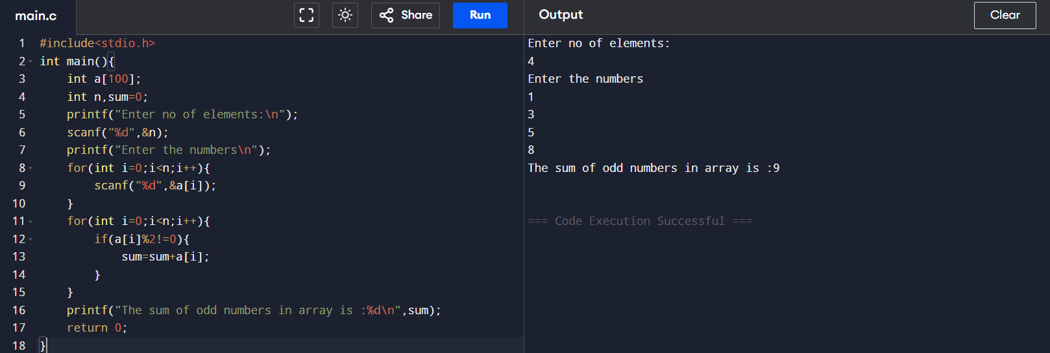

Program 8 - Write a C program to find the largest element in an array
#include <stdio.h>
int main() {
int a[100], n, i, large;
printf("Enter number of elements: ");
scanf("%d", &n);
printf("Enter %d elements:\n", n);
for(i = 0; i < n; i++) {
scanf("%d", &a[i]);
}
large = a[0];
for(i = 1; i < n; i++) {
if(a[i] > large) {
large = a[i];
}
}
printf("The largest element in the array is = %d\n", large);
return 0;
}

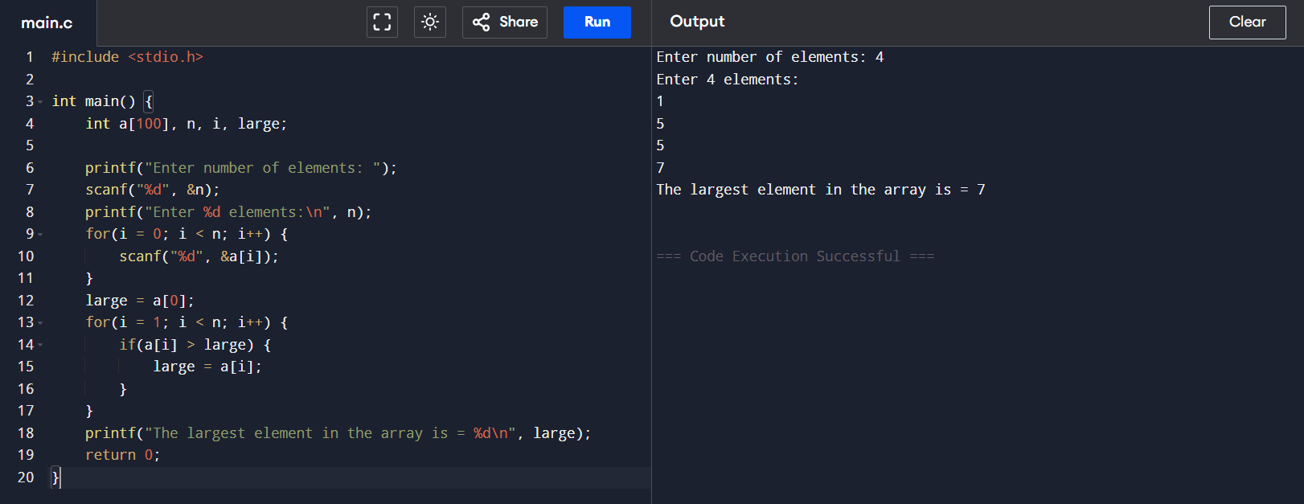

Program 9 - Write a C program to Initialize an array with some element , Find the sum and average and display it
#include <stdio.h>
int main() {
int a[5];
int sum = 0;
float average;
printf("Enter 5 integers:\n");
for(int i = 0; i < 5; i++) {
scanf("%d", &a[i]);
}
for(int i = 0; i < 5; i++) {
sum += a[i];
}
average = (float)sum / 5;
printf("\nArray elements are:\n");
for(int i = 0; i < 5; i++) {
printf("%d ", a[i]);
}
printf("\nSum = %d\n", sum);
printf("Average = %.2f\n", average);
return 0;
}
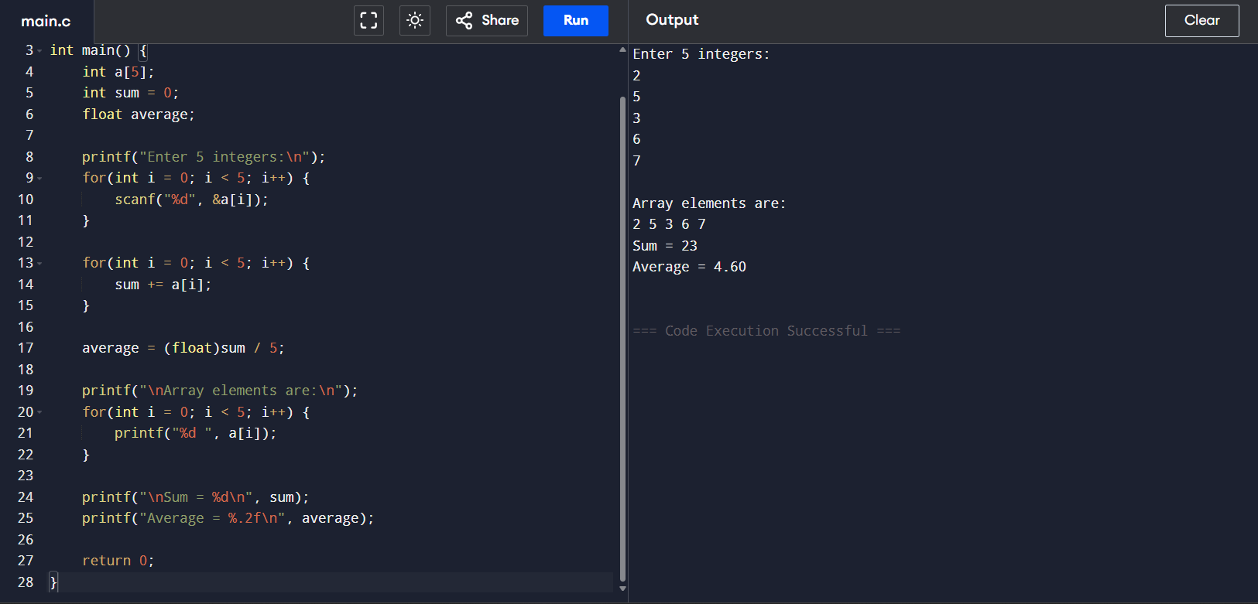

Program 10 - Write a C program to search an element from a array

#include <stdio.h>
int main() {
int n, i, search, found = 0;
printf("Enter the number of elements in the array = ");
scanf("%d", &n);
int a[n];
printf("Enter %d elements:\n", n);
for(i = 0; i < n; i++) {
scanf("%d", &a[i]);
}
printf("Enter the element to search: ");
scanf("%d", &search);
for(i = 0; i < n; i++) {
if(a[i] == search) {
printf("Element %d found at index %d.\n", search, i);
found = 1;
break;
}
}
if(!found) {
printf("Element %d not found in the array.\n", search);
}
return 0;
}
